CAUSE FOR CONCERN LOG
Terapia School Services and The Bothy Placements

Trainee Therapist Name

Client Code

Name of School

Date of the Incident

Cause for Concern (Please give brief and non-clinical reasons for your concern)
Who have you reported this to?  Please highlight and add the date when the concern was reported: | School Safeguarding Lead  Terapia Supervisor  Terapia Safeguarding Lead  Social Services  GP  Other (please specify) ………………………………………………………

Date of report

Do you know what the outcome of you reporting was?

Page 1 of 2

Terapia will follow up with you to ensure that you are satisfied that your cause for concern has been managed, in addition to notifying the Terapia School Services, you are expected to bring your concern to supervision.

When you have completed this form please encrypt it using the information below and send it back to Terapia’s Director of Therapeutic Services at sacha@terapia.co.uk and Head of School Services at pamela@terapia.co.uk

Please send your encryption password separately to the encrypted document.

How to set a password in a Word document:
To encrypt your file and set a password to open it:
- Click the Microsoft Office Button , point to Prepare, and then click Encrypt Document. Or in Microsoft Word, select File, Info, then Protect Document, Encrypt with Password.
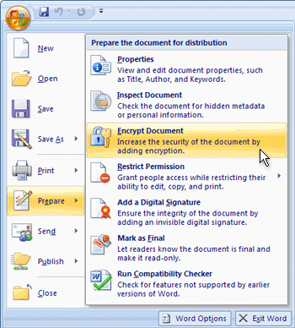

- From the Encrypt Document/Encrypt with Password dialogue box, in the Password box, type a password, and then click OK.
CAUTION: Keep your password in a safe place. If you lose or forget the password, it cannot be recovered. Encryption is a standard method used to help make your file more secure.
- The Confirm Password dialogue box will ask you to Re-enter Password in the box, type the password again, and then click OK.
- To save the password and encrypt the document, save the file.
- Remember to send the password chosen in a separate email to the document to both sacha@terapia.co.uk and pamela@terapia.co.uk

