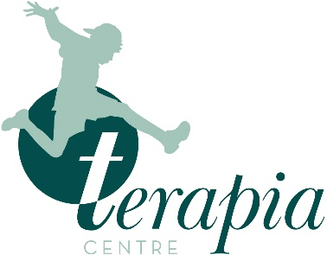
SMHL training
booking form
Please complete the form below to book on to Terapia’s Senior Mental Health Lead training
First Name:
Surname:
School / College:
School / College Address:

Postcode:
School / College Telephone:
Mobile:
Email Address:

Preferred Training Location: | London |  | North East |  | North West
 | East of England |  | South East |  | South West
 | East Midlands |  | West Midlands |  | Online (via Zoom)

Please rate your level of experience in each of the following learning outcome areas
(1 = beginner 2 = intermediate 3 = advanced 4 = expert)
Leadership and management |  | Identifying need and monitoring impact of interventions
Creating an ethos and environment |  | Targeted support and appropriate referrals
Staff development |  | Working with parents, carers and families
Curriculum, teaching and learning |  | Enabling student voice

How did you learn about Terapia’s SMHL training? |  |  |  | Social media:
Direct mail from Terapia |  | Word of mouth |  | Facebook
Search Engine |  | Leaflet |  | Twitter
Terapia Website |  | Education event |  | Instagram
Other – please specify: |  |  |  | LinkedIn

Print Name:
Signature: |  | Date:
Return your completed form to contact@terapia.co.uk or call Jonathan Block: 07795 297921.

